DATA STRUCTURE (KCS-301)

LAB PRACTICAL FILE

NAME : SHIVANGI YADAV

ROLL NO : 1901610100194

**AIM**-Write a program in c to perform linear search

**PROGRAM-1**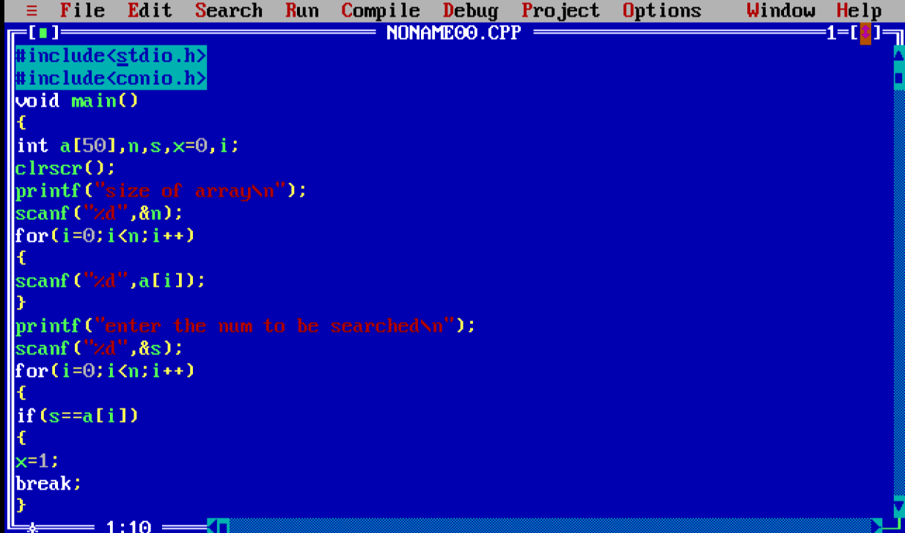

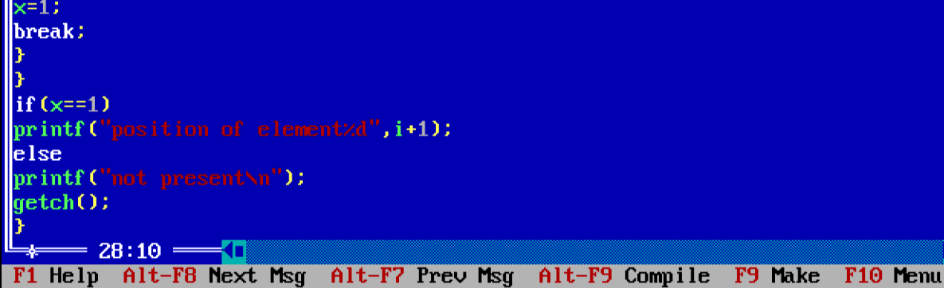

**0UTPUT**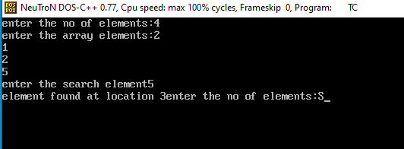

**AIM- Write a program to perform binary search in c.**

**PROGRAM-2**

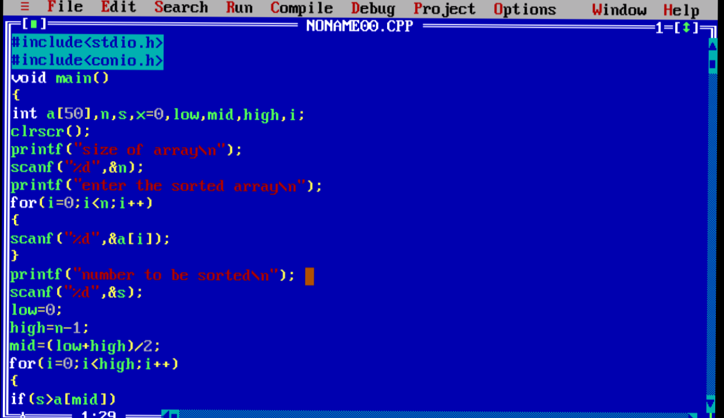

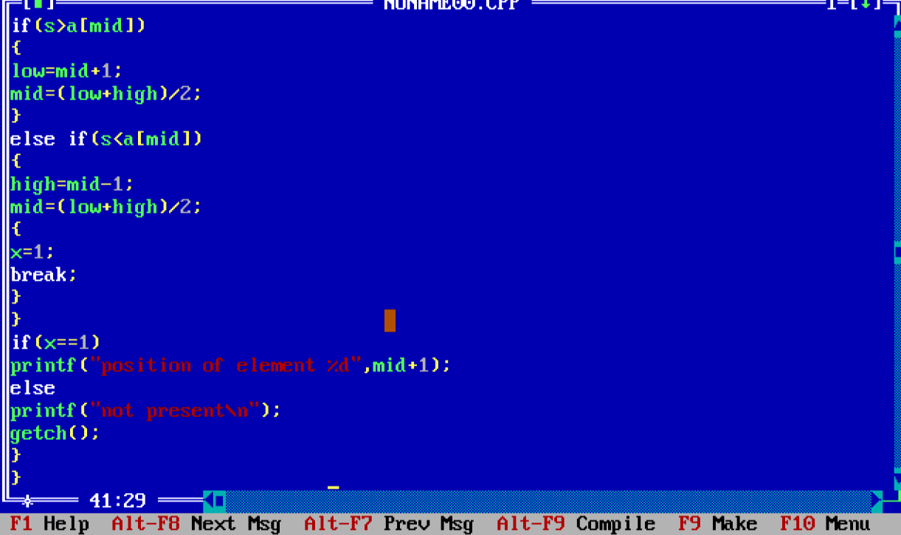

**OUTPUT-**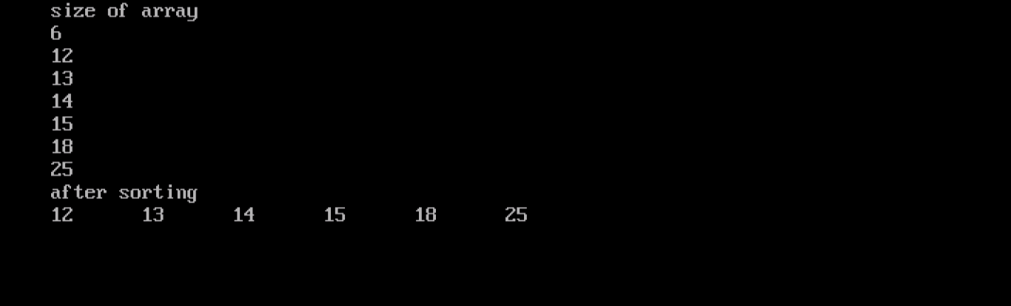

**AIM-Write a program in c for transverse of array**

**PROGRAM-3**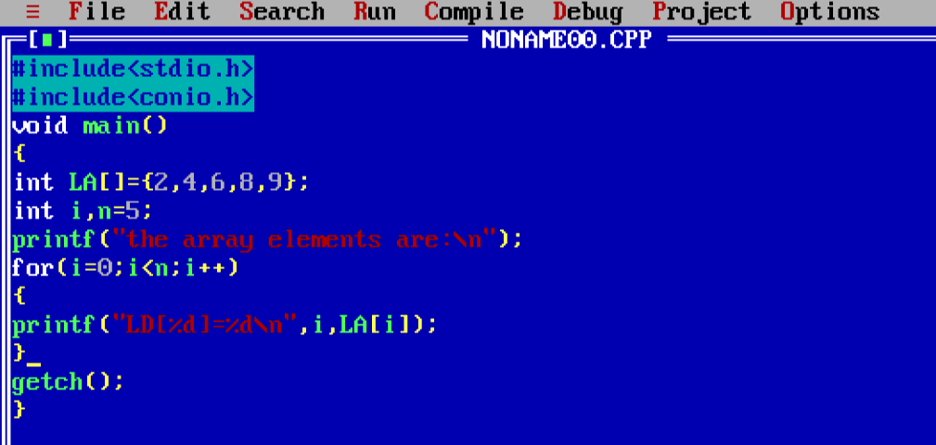

OUTPUT-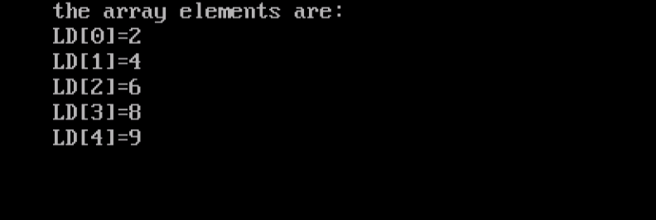

**AIM –Write a program in c for INSERTION sort.**

**PROGRAM-4**

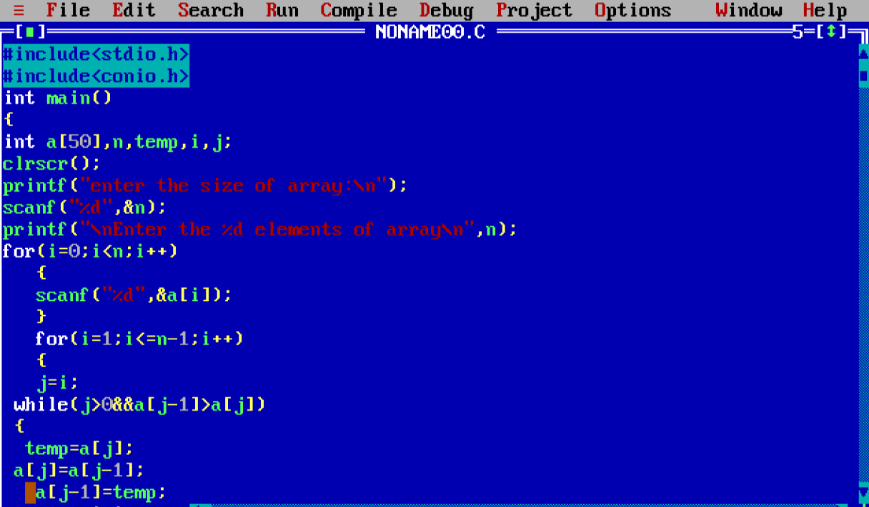

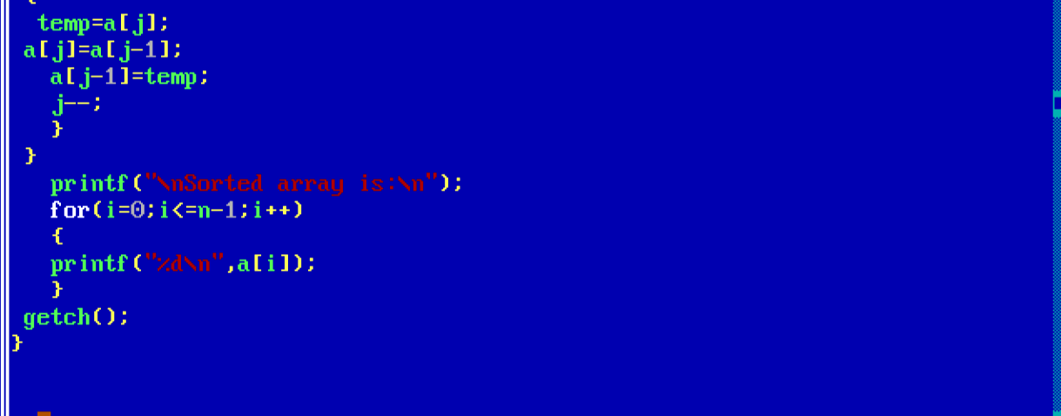

**OUTPUT-**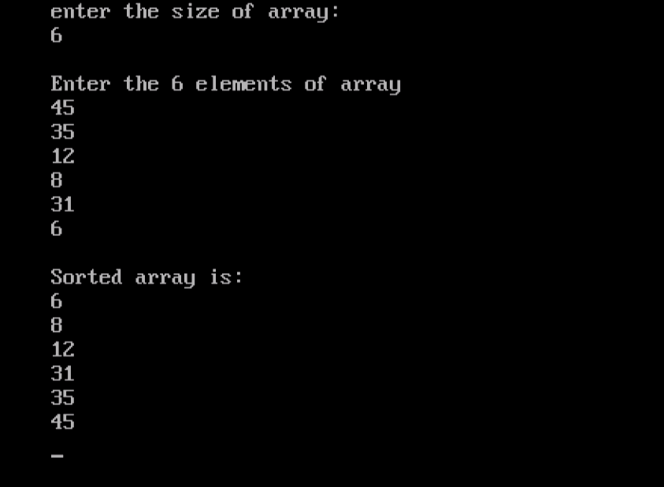

**SHIVANGI YADAV**

**ROLL NO -1901610100194**

**AIM –Write a program in to perform selection sort.**

**PROGRAM-5**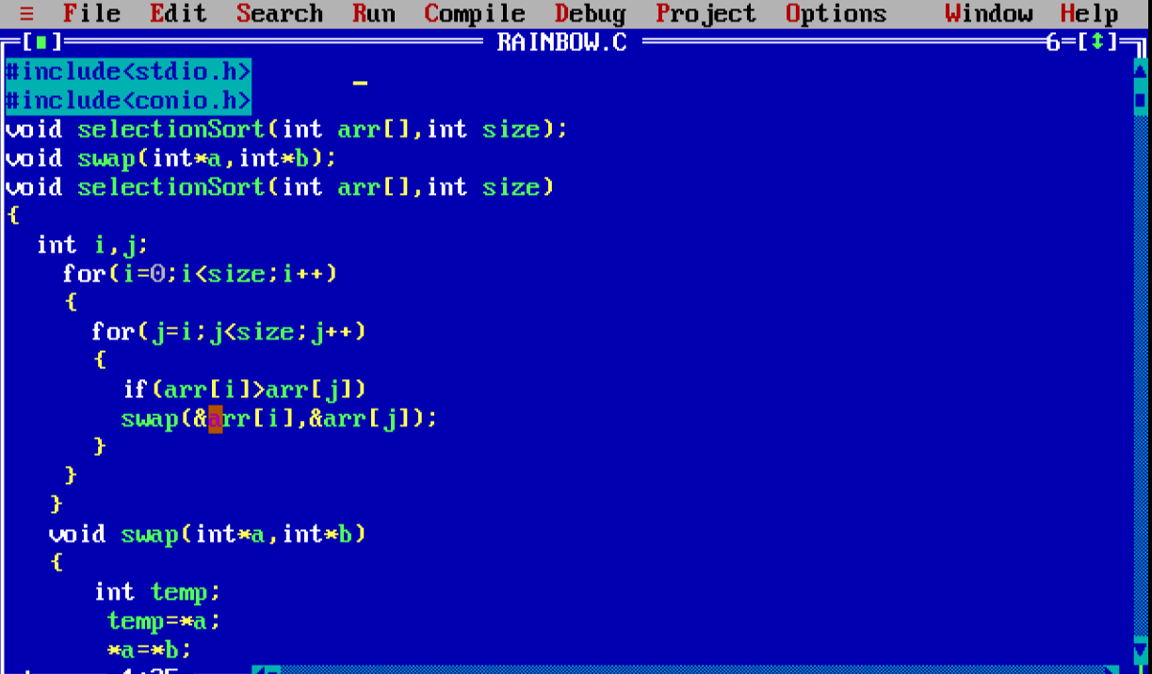

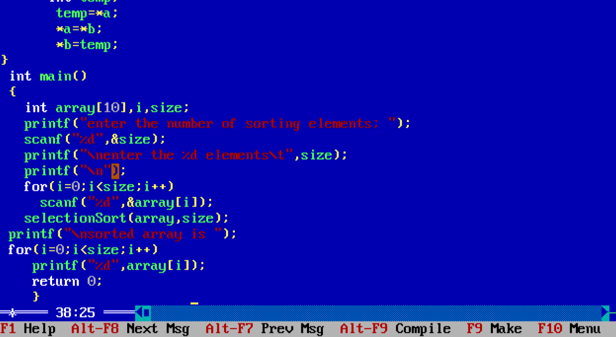

**OUTPUT-**